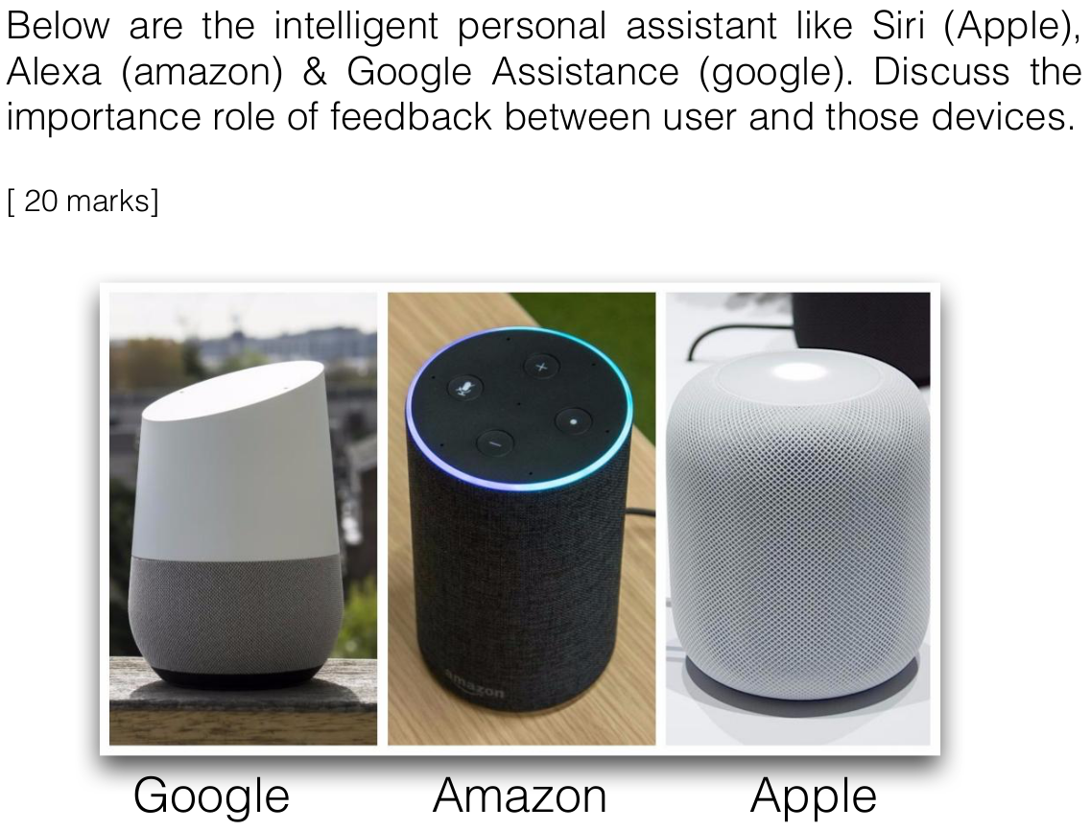

This kind of human-computer interaction is fairly new to everyone in the market, previously humans are used to interact with computers through touchscreen or keyboard and mouse. To build cognition with the users, feedback from the devices are very important especially for intelligent personal assistances, this is due to the fact that they aren’t able to provide physical feedback such as keyboard or touchscreen. For example, to interact with Google Home, just say “OK Google” and it will be ready to respond, it is fast and convenient, you can be doing house chores and interacting with it at the same time. Therefore, intelligent personal assistances need to have the capability to understand what the users want through voice communications and this is done through implementing Machine Learning. To give an illustration to my point, instead of saying “Turns on the light and change its color”, users can say “Party Time!” and the personal intelligent assistances turns on the light and change its RGB color, this is how they learn to understand the users overtime. Moreover, through the help of Artificial Intelligence (A.I.) every personal intelligent assistance has their own personality, this is because they are able to remember the user’s context. For example, users can ask “What’s the best Chinese restaurant near me?”, it follows up with “How about Japanese restaurants?”. This example is in the context that the users had asked about Japanese food in the past. Last but not least, most of these devices are customizable, users are able to set certain voice commands and the assistances automate the process for them. For example, users can set “I want to sleep” as a special voice command where the assistances turns off the light and play a relaxing song for the users. All in all, feedback between user and personal intelligent assistances is very important to build the cognition between them and reliance of the users towards the devices.